QUEUE MANAGEMENT SYSTEM IN A RESTAURANT
A PROJECT REPORT BY
TEAM NO. 1

DARSH JASORIA (S24CSEU0844)
MAHAK SONI (S24CSEU2741)
DEV NIRWAN (S24CSEU0835)
DIVYANSH DWIVEDI (S24CSEU0854)


SUBMITTED TO

SCHOOL OF COMPUTER SCIENCE ENGINEERING AND TECHNOLOGY, BENNETT UNIVERSITY
GREATER NOIDA, 201310, UTTAR PRADESH, INDIA

April 2026

DECLARATION
- We hereby declare that the work which is being presented in the report entitled “Queue Management System In A Restaurant”, is an authentic record of our own work carried out during the period from February, 2026 to April, 2026 at School of Computer Science and Engineering and Technology, Bennett University Greater Noida.
- The matters and the results presented in this report has not been submitted by us for the award of any other degree elsewhere.

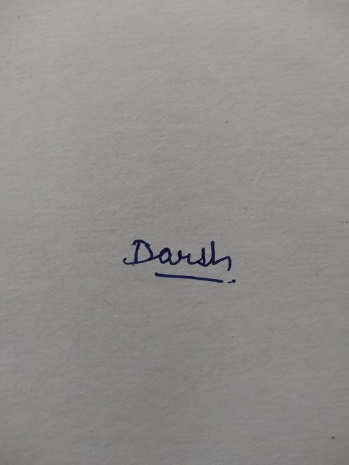
Darsh Jasoria
(Enroll. No. S24CSEU0844)

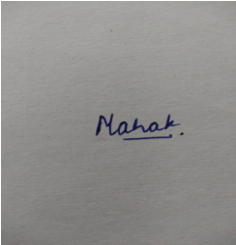
Mahak Soni
(Enroll. No. S24CSEU2741)

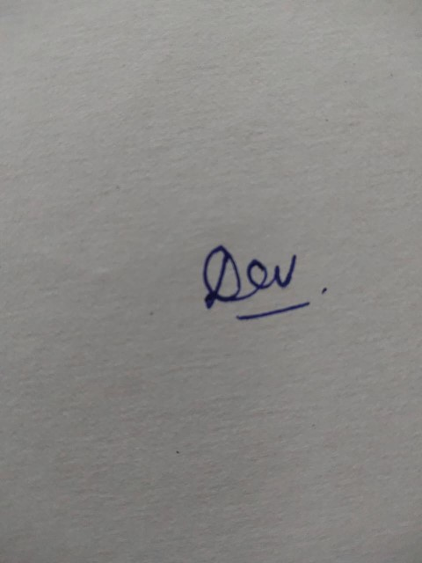
Dev Nirwan (Enroll. No. S24CSEU0835)
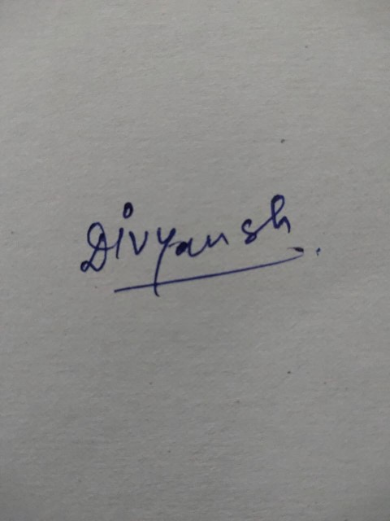
Divyansh Dwivedi
(Enroll. No. S24CSEU0854)

ACKNOWLEDGEMENT
We would like to take this opportunity to express our deepest gratitude to our mentor, Dr.
Radha Rani for guiding, supporting, and helping us in every possible way. We were extremely fortunate to have her as our mentor as she provided insightful solutions to problems faced by us thus contributing immensely towards the completion of this capstone project. We would also like to express our deepest gratitude to VC, DEAN, HOD, faculty
members and friends who helped us in successful completion of this capstone project.


Darsh Jasoria
(Enroll. No. S24CSEU0844)
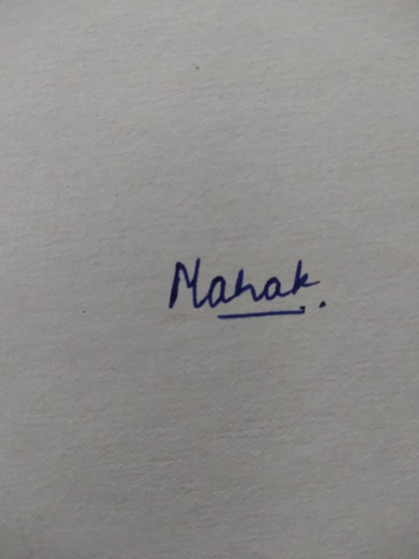
Mahak Soni
(Enroll. No. S24CSEU2741)

Dev Nirwan (Enroll. No. S24CSEU0835)

Divyansh Dwivedi
(Enroll. No. S24CSEU0854)

TABLE OF CONTENTS
LIST OF TABLES ......................................................................................................................... vi
LIST OF FIGURES ...................................................................................................................... vii
LIST OF ABBREVIATIONS ...................................................................................................... viii ABSTRACT ................................................................................................................................... ix
- INTRODUCTION ...................................................................................................................... 1
  - Problem Statement ............................................................................................................... 2
- Background Research ................................................................................................................. 4
  - Proposed System .................................................................................................................. 4
  - Goals and Objectives ............................................................................................................ 6
- Project Planning .......................................................................................................................... 6
  - Project Lifecycle .................................................................................................................. 7
  - Project Setup ........................................................................................................................ 7
  - Stakeholders ......................................................................................................................... 7
  - Project Resources ................................................................................................................. 8
  - Assumptions ......................................................................................................................... 9
- Project Tracking .......................................................................................................................... 9
  - Tracking ............................................................................................................................... 9
  - Communication Plan .......................................................................................................... 10
  - Deliverables ........................................................................................................................ 11
- SYSTEM ANALYSIS AND DESIGN ..................................................................................... 12
  - Overall Description ............................................................................................................ 12
  - Users and Roles .................................................................................................................. 13
  - Design diagrams/ UML diagrams/ Flow Charts/ E-R diagrams ........................................ 13
    - Use Case Diagrams ...................................................................................................... 15
    - Class Diagram ............................................................................................................. 16
    - Activity Diagrams ....................................................................................................... 16
    - Sequence Diagram ....................................................................................................... 17
    - Data Architecture ......................................................................................................... 18
- User Interface ............................................................................................................................ 19
  - UI Description .................................................................................................................... 19
  - UI Mockup ......................................................................................................................... 20
- Algorithms/Pseudo Code .......................................................................................................... 22
- Project Closure .......................................................................................................................... 23
  - Goals / Vision ..................................................................................................................... 23
  - Delivered Solution .............................................................................................................. 23
  - Remaining Work ................................................................................................................ 24
REFERENCES ............................................................................................................................. 25

LIST OF TABLES
Table Page
Table 1: Goal and Objectives .......................................................................................................... 6
Table 2: Sample 2 ........................................................................................................................... 7
Table 3: Sample 3 ........................................................................................................................... 7
Table 4: Sample 4 ........................................................................................................................... 8
Table 5: Sample 4 ........................................................................................................................... 9
Table 6: Sample 6 ......................................................................................................................... 10
Table 7: Regularly Scheduled Meetings ....................................................................................... 10
Table 8: Information To Be Shared Within Our Group ................................................................ 11
Table 9: Information To Be Provided To Other Groups ............................................................... 11
Table 10: Information Needed From Other Groups ..................................................................... 11
Table 11: Deliverables .................................................................................................................. 11 Table 12: Sample 12 ..................................................................................................................... 13

LIST OF FIGURES
Figure Page
Figure 1: Sample use-case diagram .............................................................................................. 15
Figure 2: sample 2 ......................................................................................................................... 16
Figure 3: sample 3 ......................................................................................................................... 16
Figure 4: Sample 4 ........................................................................................................................ 17
Figure 5: Sample 5 ........................................................................................................................ 18 Figure 6: Sample 6 ........................................................................................................................ 22

LIST OF ABBREVIATIONS
Abbreviation ..................................................Explanation of the Abbreviation
AAA Authentication Authorization and Access Control
CSP Cloud Service Provider
DNS Domain Name System
IAM Identity and Access Management

ABSTRACT
Abstract: Queue management system is applied to the restaurant industry where customers have to wait for long queues and face difficulties due to manual booking issues. For example, In Queue systems Customers have to wait without any real-time ETA and Also face frustration when order food for tables. There are number of fields where queue management systems are faster and convenient. It also provides seat pre-booking and less waiting time. This project aims to reduce manual workload by developing a web-application that allows the users to Register themselves on the system, Book table, place food order, Get real-time update on food delivery. Users can simply book tables and order food using web-application and get notified about their queue number and time to ease their process. Restaurant also benefits from this as it easy to keep track of orders and bookings. The Technologies used are HTML, CSS, JavaScript for frontend, Flask for backend and SQLite database to store customer data, Booking data and order details. APIs Used are Twilio (OTP Authentication) and Google Maps (Real time update on order location). Using the proposed solution, waiting time for the customers can be easily managed and improves the overall experience of the customer as well as the restaurant. In Future this project can be scaled up by adding features like Artificial Intelligence and can be made into an Android app.

1. INTRODUCTION
- The way businesses work has changed a lot because of technologies, especially for restaurants and other services. Restaurants need to be quick and efficient to make customers happy and keep them coming. Many restaurants still use old ways to manage lines, reservations and orders which can cause long waits and problems with customers.
- When it is busy customers often have to wait a time because there are too many people and no good system to manage the line. Booking a table by hand takes a lot of time. Can have mistakes making it hard for restaurants to handle a lot of customers. Also customers do not get updates on when their table's ready or the status of their order, which can be frustrating.
- To fix these problems people have started using something called a Queue Management System. This system uses computers to manage table bookings orders and lines all in one place. It has features like booking tracking things in real time and sending automatic messages which makes things easier for restaurants to run and makes customers happier.
- This project is about making a Queue Management System for restaurants that people can use on the web. It lets people book tables ahead of time place orders on the computer and see where their order is in time. The system is meant to reduce wait times make service better and make running a restaurant easier. By using web technology this solution is a good way to manage restaurant services in a better way.
- The Queue Management System is a help to restaurants because it makes things more efficient. Restaurants can use the Queue Management System to manage their services. The Queue Management System is also good for customers because it reduces wait times and makes things easier for them. Overall the Queue
Management System is a solution, for restaurants to use.

1.1. Problem Statement
- In restaurants they still manage customers the way during busy hours.
- This means people have to stand in lines and it gets really confusing.
- Customers usually wait without knowing how long it will take to get a table, which's super frustrating.
- Sometimes it's so bad that people just leave because they can't wait anymore.
- The old way of booking tables is really slow.
- It doesn't always work, especially when there are customers.
- Restaurant staff have a time managing reservations orders and lines all at once without the right tools.
- Another big problem is that customers don't get updates about their table or food orders on time.
- Because of these problems both customers and restaurant staff have a time during peak hours.
- This shows that we need a system to handle lines, bookings and orders better.
- A web-based Queue Management System is needed to make things simpler reduce waiting time and make the experience better for everyone.
- The Queue Management System will help restaurants manage queues, bookings and orders which's what it's all about.
- The Queue Management System will make it easier for customers to wait and for restaurants to manage their customers.
- The Queue Management System is what restaurants need to make things better for everyone.
- The Queue Management System will make the experience better for customers. It will make things easier, for restaurant staff.

2. BACKGROUND RESEARCH
- In todays time technology is really helping to improve services in industries especially in restaurants. Many restaurants are trying to move from traditional methods and use digital systems to manage customers more efficiently. Earlier most restaurants handled bookings and queues by hand, which often caused confusion long waiting times and poor management during hours.

- From looking at online platforms and existing systems it is clear that many solutions already exist for table booking and food ordering. For example some applications let users reserve tables in advance while others focus on food delivery services. These systems have helped to some extent. They are usually separate and do not provide a complete solution in one place.

- Another important thing we found out from research is that customers prefer systems where they can get real-time updates. Knowing the waiting time table availability or order status makes the experience much smoother and less frustrating for the customers. Technologies like web applications, databases and APIs have made it easier to build smart systems. Features like OTP verification for login and live tracking using maps are now commonly used to improve the user experience of the Queue Management System.

- However most of the existing systems still have limitations. They do not combine all the features such as queue management, table booking, food ordering and delivery tracking into a single platform. Because of this both customers and restaurant staff still face difficulties in managing everything with the existing Queue Management System.

- After understanding these problems and gaps it became clear that there is a need for an more integrated Queue Management System. This motivated us to develop a Queue Management System that can handle all these tasks together in an effective way.

- The main idea behind this project is to make the process easier for both customers and restaurant staff by using a platform for the Queue Management System. By combining features into one system it helps reduce waiting time improves service quality and provides a better overall experience, for the customers and the restaurant staff using the Queue Management System.

2.1 Proposed System
- The main purpose of this project is to create a Queue Management System for the web that helps restaurants manage customers efficiently and reduce waiting time. This system is designed to solve the problems of queues, mistakes when booking tables and not having real-time information that customers usually face when they go to traditional restaurants.

- This system lets users sign up book tables of time place orders for food and see the status of their orders in real time. It puts all these features in one place making things simple and easy for customers and restaurant staff. The Queue Management System automatically manages the queue. Gives updates, about when tables are available and how orders are coming along.

- When customers use this Queue Management System they can save time. Avoid waiting for no reason while restaurants can handle more customers easily especially when it is really busy. It also reduces the amount of work that has to be done by hand. Makes managing bookings and orders more accurate.

- Overall the goal of this project is to create an easy to use Queue Management System that makes the service better makes customers happier and makes running a restaurant more organized and efficient.

2.1. Goals and Objectives

Table 1: Goal and Objectives
# | Goal or Objective
1 | We want to reduce waiting time with a Queue Management System that works automatically.
2 | We want to make it easy for people to book tables online through the Queue Management System.
3 | We want to give people updates away about whether a table is available and the status of their order through the Queue Management System.
4 | We want people to be happy with the Queue Management System by making everything smooth and easy to understand.
5 | We want to reduce mistakes that happen when people book tables and order food by using the Queue Management System.
6 | We want to create a way for people and restaurant staff to use the Queue Management System.
7 | We want to put everything. Booking, Ordering and Tracking. Into one place, with the Queue Management System.
8 | We want to help restaurants manage a lot of customers during times with the Queue Management System.

3. PROJECT PLANNING
- This section is about how we planned and organized the project from start to finish.
- We used an approach to develop the project and we used various tools and technologies.
- We had to manage tasks in a specific way to keep everything on track.
- The section also talks about the roles of people involved in the project what resources we needed and what we assumed during development.
- Good planning helped us finish the project in a manner and made sure we achieved all our goals.
- The planning process was crucial, for the projects success.
- It ensured that we completed the project efficiently.

3.1. Project Lifecycle
- For this project we used the way of doing things to make sure we could change and get better all the time. We did not do the project at the same time. The Agile development approach helped us to divide the work into parts. This made it easier to manage and improve the project step by step.
- At the start we tried to understand what the problem was and what people needed. We did this by gathering requirements based on user needs for the Agile development approach. Then we made a plan and started working on the main things like user registration, table booking and order management for the project using the Agile development approach.
- The Agile development approach was used in stages. In each stage we added things tested them and made changes based on what people said. We talked to each other in the team all the time. This helped us find problems early and make the system better all the time using the Agile development approach.
- Finally after we finished all the things we tested everything and made some last changes. We did this to make sure the system works well. The Agile development approach helped us build the project in an efficient way. It also let us make changes and improvements, throughout the project using the Agile development approach.

3.2. Project Setup

Table 2: Sample 2
# | Decision Description
1 | Website was made using HTML, CSS and JavaScript for the design.
2 | We used For the backend work Python and Flask.
3 | We are using SQLite to store all the data for the website.
4 | For coding we use Visual Studio Code and GitHub to save all the code for the project.
5 | The website project runs on a server, which is the server, on our own computer.

3.3. Stakeholders

Table 3: Sample 3
Stakeholder | Role
Dr. Radha Rani | Mentor, Support and Feedback, Guidance
Darsh Jasoria | Full Stack, Backend Integration, Data Analysis
Mahak Soni | Research, Report, UI/UX, SQLite
Dev Nirwan | Frontend, PPT, Testing Implementation
Divyansh Dwivedi | System Design, Database, Deployment

3.4. Project Resources
- In this project we need some things to make it work well.
- The main things we need are people to work on it.
- They will. Build the application.
- We also need a computer or laptop to write code and test it. o For software we use tools, like Visual Studio Code to build it.
o We use GitHub to keep all the code safe and organized o We use Flask with Python for the backend and SQLite to store data.
- We also need internet to use some services.
- For example we use Twilio for sending OTP verification messages. Google Maps to track locations.
- All these things help us build and run the project properly.

Table 4: Sample 4
Resource | Resource Description | Quantity
Laptop or Computer | We used this for coding, testing and running the Project. | 1 or more
Project Team members | These are the students who worked together to make this Project. | 4
Mentor (Dr.  Radha  Rani) | Our Mentor gave full guidance whenever we needed by directly talking to us and she helped us in making the Project. | 1
Software Tools | We used VS Code, Flask and SQLite to make this Project. | 1 set
Internet  Connection | This was necessary for using API’s, doing research and testing. | 1
Mobile Phone | We used this for testing and some WhatsApp Messages for sharing information about our Project work. | 4

3.5. Assumptions
- In this project we think that all team members will do their job and finish their work on time. We also think that team members have the things they need like a laptop, internet and software.
- We think that things like Twilio and Google Maps will work correctly and not cause problems. The project will be done within the time we have. We do not expect to have big technical problems, with the project. We expect the project to be finished on time. We think that Twilio and Google Maps will work fine. Table 5: Sample 4
# | Assumption
A1 | We will have team meetings and collaborate closely.
A2 | We will have all the software and tools at our disposal.
A3 | Team members will quickly get to grips with the tools.
A4 | We were confident that the project will be finished on schedule.
A5 | API’s such as Twilio and Google Maps will function as expected.
A6 | We expect the internet and system to be reliable, with issues.
A7 | The system will perform correctly. Can be refined later on.

4. PROJECT TRACKING

4.1. Tracking
- During this project we tracked progress regularly. This ensured that all tasks were completed on time and the system worked properly. The project code was managed using Git. It was stored on GitHub. This allowed all team members to collaborate easily. They could keep track of changes.
- We had team discussions and meetings. We reviewed progress, identified issues and planned the steps. Any bugs or errors found during development were fixed.
We did this through testing and debugging, at each stage of the project.

- The project was tested continuously. We made sure that all features worked correctly. These features included table booking order placement and delivery tracking. All important project files and documents were properly maintained.
They were shared among team members.
- This approach helped keep the project organized. It improved teamwork. It ensured that the final system was reliable and efficient.

Table 6: Sample 6
Information | Description | Link
Code Storage | We store our project code on GitHub. | https://github.com/MahakSoni05/MahakSoni05Queue-Management-System-In-Restaurant
Bug Tracking | We track bugs either manually or by using notes and GitHub issues on GitHub. | https://github.com/MahakSoni05/MahakSoni05Queue-Management-System-In-Restaurant
Project  Assignments | We save our reports and documents either on our system or, on GitHub. You can check the GitHub. | https://github.com/MahakSoni05/MahakSoni05Queue-Management-System-In-Restaurant
Continuous Integration | We test our project manually during development. | -
Regression Testing | We do testing to check for errors. | -

4.2. Communication Plan

Table 7: Regularly Scheduled Meetings
Meeting Type | Frequency/Schedule | Who Attends
Online Discussion using Google Meet or WhatsApp | Weekly | The Project Team and our Mentor
Team Meeting | Every Week | Project Team Members
Short Meeting that take place in the class | Weekly in class time | Project Team Members
Planning Meeting | At the beginning of this project | The Project Team and our Mentor
Review Meeting | After each part of project is completed | Project Team and our Mentor
Final Review Meeting | After end of the project | The Project Team and our Mentor

Table 8: Information To Be Shared Within Our Group
Who? | What Information? | When? | How?
Project Team | The Project Team needs to share task updates and progress of the Project Team work, Project Team needs to talk about any issue we faced during development of the Project Team work | Every Week whenever we needed to discuss anything about our project | Team meetings using WhatsApp group and  Google meet

Table 9: Information To Be Provided To Other Groups
Who? | What Information? | When? | How?
Mentor (Dr. Radha Rani) | Final Project Work  (Report, Code,  Presentation) | When the Project work was completed | Submission and Presentation
Mentor (Dr. Radha Rani) | Weekly Progress of the Project Work | Every Week | Meetings or Simple Discussions
Mentor (Dr. Radha Rani) | Project Work Completed | After completing each part of the Project Work | Showing demo of the Project Work

Table 10: Information Needed From Other Groups
Who? | What Information? | When? | How?
Mentor (Dr. Radha Rani) | Guidance and Help related to out Project Work | Whenever we needed | Talking in Meeting
Mentor (Dr. Radha Rani) | Feedback on our Project work | After showing our Project work | Discussion
Mentor (Dr. Radha Rani) | Clearing our doubts about the Project work | During Project Work | Asking directly

4.3. Deliverables

Table 11: Deliverables
# | Deliverable
1 | Understanding of the Project
2 | Project Code
3 | Testing and results
4 | How we built the Project
5 | How to run the Project
6 | Simple User Guide
7 | What did we learn from this Project
8 | Final Report and The Presentation

5. SYSTEM ANALYSIS AND DESIGN
• This part tells us about the system. How it works. The system is made up of parts. These parts are connected to each other. This section gives us an idea of what the system looks like and how all the parts of the system work together. It helps us understand the system by explaining how all the different parts of the system are connected.

5.1. Overall Description
- This project is a web-based system that helps restaurants manage queues better. It makes restaurant services more organized and efficient.
- Customers can book tables, place orders. Check their order status without waiting in long lines.
- The main goal is to save time and make customers happy.
- The system uses web technologies like o HTML o CSS
o JavaScript o Python with Flask
- It stores data like o user details
o bookings o orders in a database.
- The system has features, like o login o table booking o real-time updates that make it easy and reliable to use.
- This system helps customers and restaurant staff.
- It makes things faster and more convenient.
- The system reduces work avoids confusion and ensures smooth management of restaurant operations.
- It helps restaurants manage their work better.
- The system makes customers and staff happy.

5.2. Users and Roles
The system is made up of kinds of users. Each user has a job to do.
- Customer: The customer can sign up log in book a table order food and see what is happening with their order.
- Restaurant Staff: The restaurant staff can take care of bookings look at what the customers have ordered and let them know how their order is doing.
- Admin: The admin is in charge of the system including information, about users, bookings and how the system runs.

Table 12: Sample 12
User | Description
Customer | The Customer books a Table and then they order food
Staff | The staff manages the orders and the bookings
Admin | Admin manages the system and takes care of it

5.3 Design diagrams/Architecture/ UML diagrams/ Flow Charts/ E-R diagrams

5.3.1 Product Backlog Items
- As a user, I want to create an account so that I can use the app.
- As a user, I want to login so that I can access my account.
- As a user, I want to add my data so that I can save the information.
- As a user, I want to see my data so that I can check it anytime.
- As a user, I want to update my data so that I can correct it.
- As a user, I want to delete my data so that I can remove unwanted information.

5.3.2 Architecture Diagram
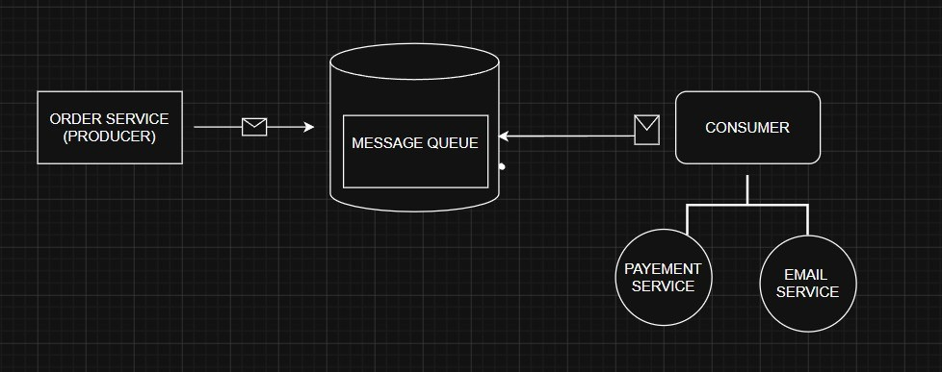

5.3.3 Use Case Diagram
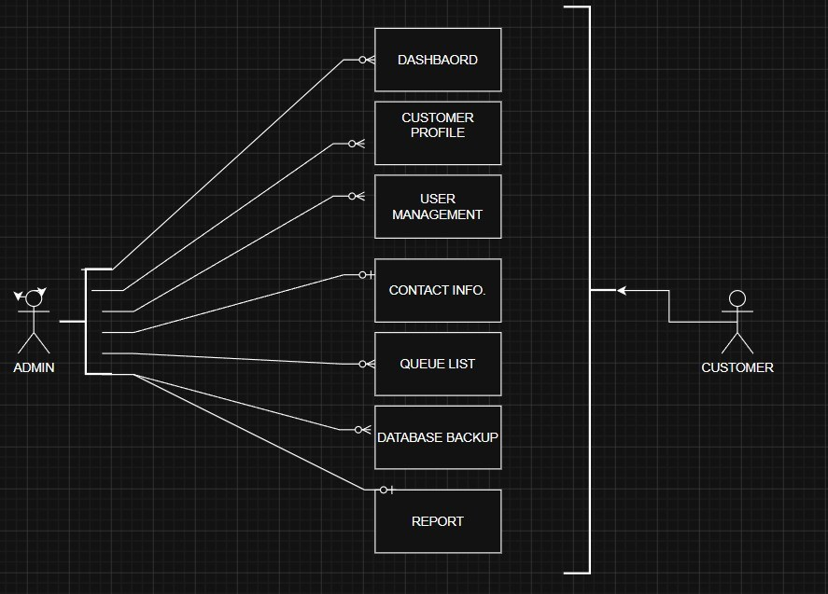

Figure 1: Sample use-case diagram

5.3.4 Class Diagram
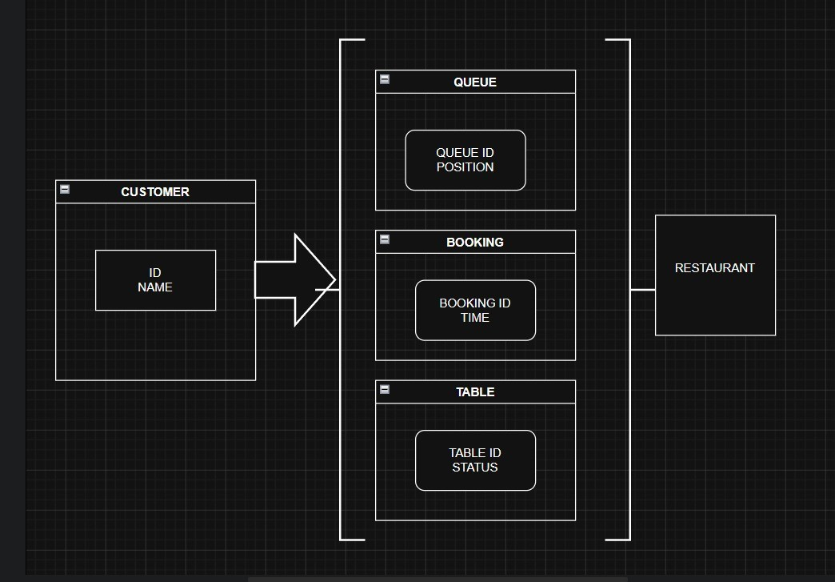

Figure 2: sample 2 5.3.5 Activity Diagrams
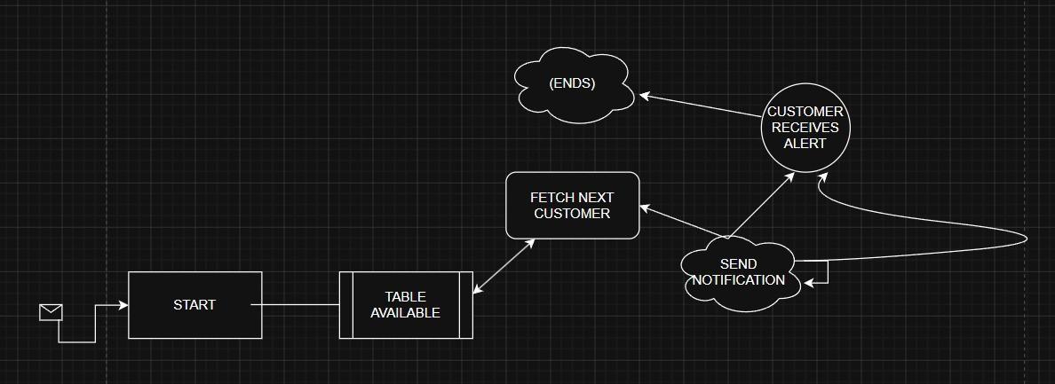
Figure 3: sample 3

5.3.6. Sequence Diagram
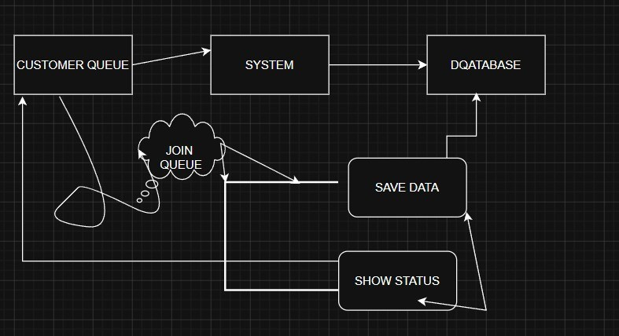
Figure 4: Sample 4

5.3.7. Data Architecture
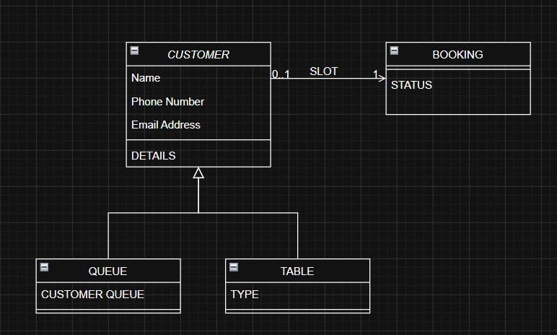
Figure 5: Sample 5

6. USER INTERFACE

6.1. UI Description
- The system is really easy to use. People can move around to parts like the login page the table booking page and the order page. Everything looks nice and simple so people can use it without getting mixed up.

- People who eat at the restaurant can log in book a table place an order and see what is happening with their order. The people who work at the restaurant can see the bookings and orders, on the system. Manage them. The system is made to make things easy and quick for everyone who uses it including the restaurant staff and the customers who come to the restaurant.

6.2. UI Mockup
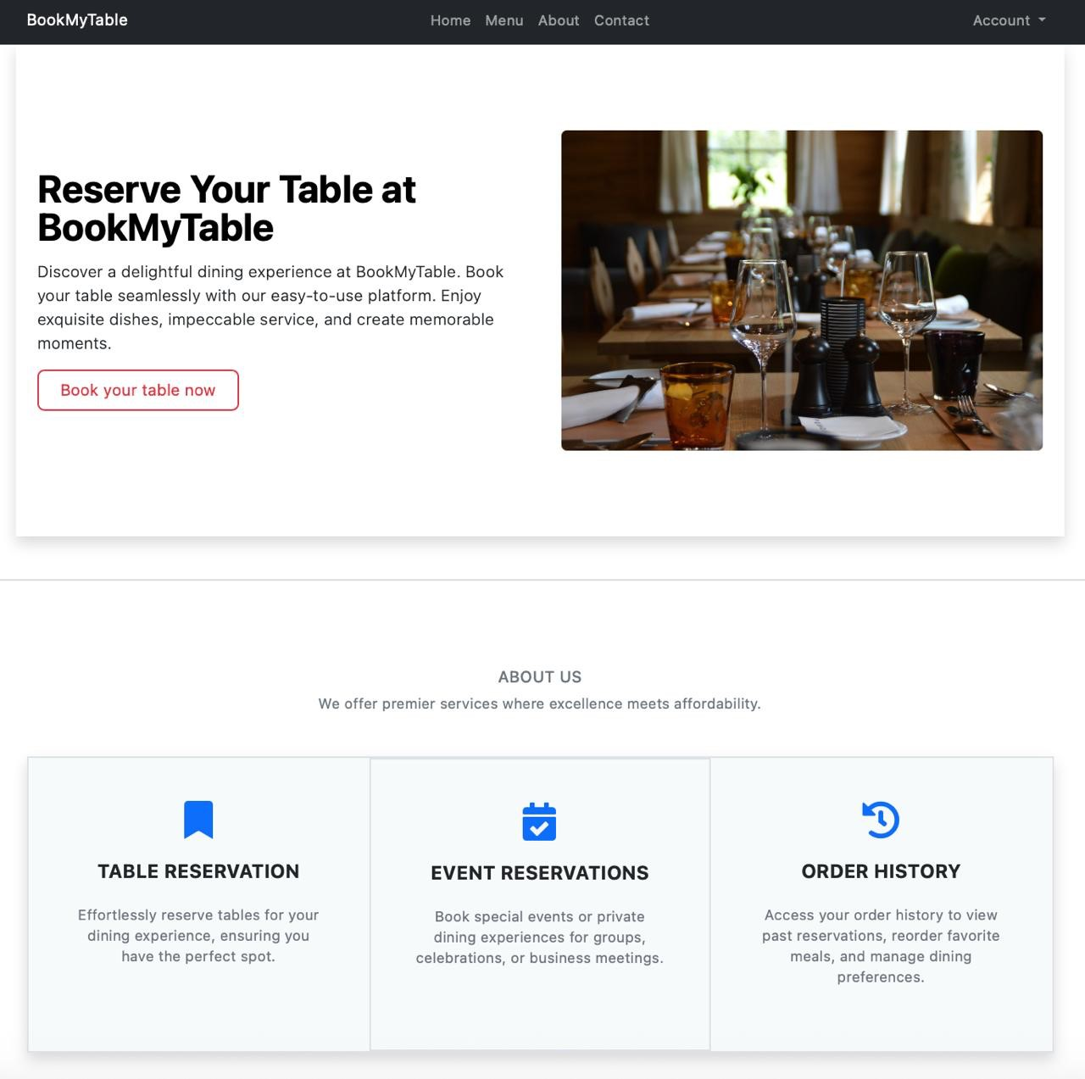
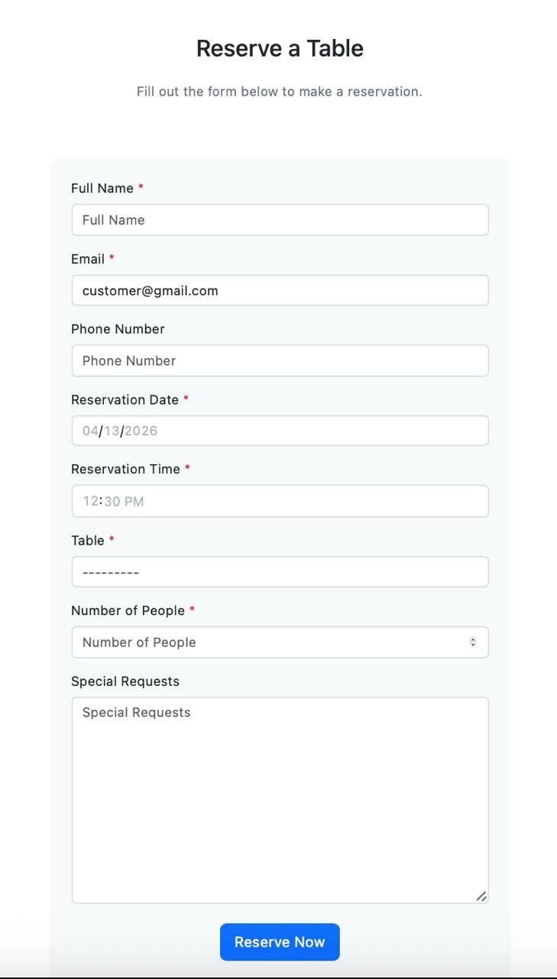
Figure 6: Sample 6

7. ALGORITHMS/PSEUDO CODE OF CORE FUNCTIONALITY

The Queue Management System works like this
- It starts
- The User opens the Queue Management System
- The User logs in. Registers with the Queue Management System
- If the User logs in successfully to the Queue Management System
→ The Queue Management System shows the User some options like book a table or place an order or track the order
- If the User selects the option to book a table with the Queue Management System
→ The User has to enter some details
→ The User saves the booking with the Queue Management System
- If the User selects the option to place an order with the Queue Management System
→ The User chooses the food items
→ The User confirms the order with the Queue Management System
- If the User selects the option to track the order with the Queue Management System
→ The Queue Management System shows the User the order status
- The staff updates the order status and the booking status with the Queue Management
System
- The Queue Management System shows the updated information, to the User
- It ends.

8. PROJECT CLOSURE
- This part of the project report is about the project. It explains what we did to complete the project.
- The project report talks about how we created the system. We also share what we learned from working on the project. The project was very helpful.
- We learned how to build an application that people can really use. We got better at programming. We also learned to work as a team.
- The project helped us learn about teamwork and programming.
- This part of the report also has some ideas for making the system better in the future. We think these ideas can make the system more helpful for users. The project and the system are important, to us. We want to make them better.
- We care about the project and the system. They matter to us.

8.1. Goals / Vision
- The main goal of this project was to create a Queue Management System. This Queue Management System is supposed to make things easier and faster for restaurant services. We wanted to make waiting time shorter and help customers book tables and place orders easily.
- During the project we made a working Queue Management System. This Queue Management System has features like booking tables placing orders and tracking orders. The Queue Management System is easy to use. It helps customers and restaurant staff.
- Overall, we did what we set out to do with the Queue Management System. We built a Queue Management System that is easy to use and it makes the restaurant experience better, for everyone who uses the Queue Management System.

8.2. Delivered Solution
- In this project we wanted to create a system that helps restaurants serve customers better and quicker. Our goal was to make people wait less and book tables and order food easily.

- We made a website where users can sign in book a table order food and see if their order is ready. Restaurant staff can also use it to manage table bookings and update what food is being ordered.
- Overall our system is simple and easy to use. It makes going to a restaurant, for customers and helps restaurant staff do their job.

8.3. Remaining Work
- The system is working fine. We can still make it better. We can add things to the system to make it more useful.
- In the future we can make the system better by adding ways for people to pay online making it look nicer and adding features. We can also make the system faster and safer.
- Overall we can keep working on the project to make it a better experience, for the system users. The system can be improved to give people a complete experience when they use the system.

REFERENCES
- I use Flask Documentation a lot it is at https://flask.palletsprojects.com/.
- I also look at SQLite Documentation the website is https://www.sqlite.org/docs.html.
- For learning HTML and CSS and JavaScript I go to W3Schools, which's at https://www.w3schools.com/.
- Sometimes I need to check Twilio API Documentation it is at https://www.twilio.com/docs.
- I also use Google Maps API Documentation the link is https://developers.google.com/maps.
- GitHub Documentation is very helpful I find it at https://docs.github.com/.
- And for web development I like to read MDN Web Docs, which's, at https://developer.mozilla.org/.

